Game Theory: Matrix Game tool

User Manual

This is the User Manual for the Matrix Game tool, a 2-Player Matrix Game simulator, primarily designed for students learning about Game Theory and Matrix Games. This is the final project for Linear Optimization (MATH 4025) with Dr. Peter Wolenski at Louisiana State University.

2016

Matthew Wolff & Sarah Baldwin

MATH 4025

5/6/2016

Table of Contents

Introduction 3

Setup 3

Game Play 5

## Introduction

Start by unzipping the MatrixGameTool.zip file with WinRar, 7zip, etc.

The **source code** can be found among the unzipped directories by following the path below.

Source code path: MatrixGameTool/src/matrixgametool/*.java  
Source files: Main.java, MatrixInterface.java, PayoffMatrix.java, and StrategySetPanel.java

*Alternatively, source code can be viewed online, here: <https://github.com/mwolff3/MatrixGameTool>*

The **executable jar file** can be found among the unzipped directories by following the path below.

Executable path: MatrixGameTool/dist/MatrixGameTool  
Executable file: MatrixGameTool (should have a little java/coffee cup icon for this file)

The **code documentation** can be found among the unzipped directories by following the path below:

Documentation path: MatrixGameTool/dist/index.html  
 Documentation file: index.html

## Setup

If not on an LSU computer, you may need to accomplish this step before running the executable file to play the Matrix Game Simulator. Make sure you have installed a Java Runtime Environment (JRE) or that your JRE is up-to-date by following the steps below:

1. Go to the Java SE download page linked below (should look like picture in step 2): <http://www.oracle.com/technetwork/java/javase/downloads/index.html>
2. Click the Download button under JRE (boxed in red below)

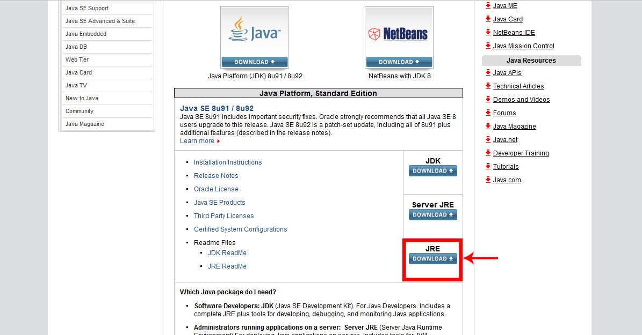

1. Under the first header “Java SE Runtime Environment 8u91”, click “Accept License Agreement” and then download the .exe file boxed in red and pictured below.

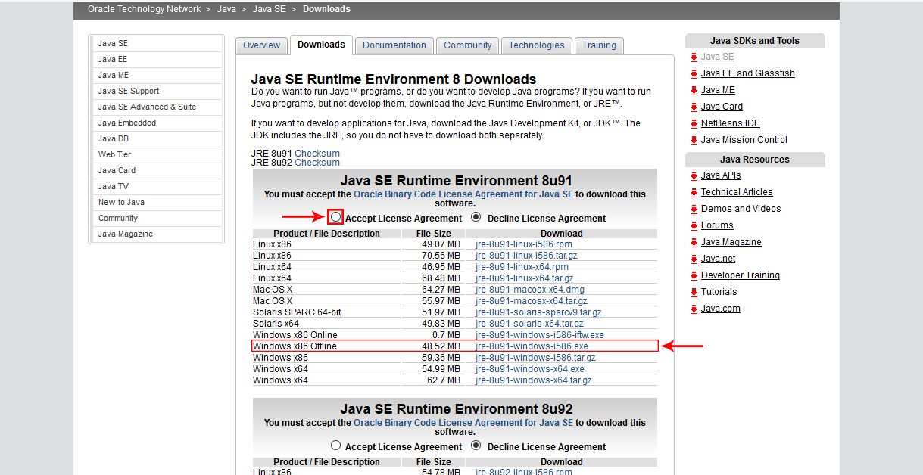

1. Locate the downloaded file, double-click, and install (using default settings).
2. If it prompts you to delete any old versions of Java, follow the steps that allow it to do so.
3. Lastly, follow the path mentioned in the introduction to navigate to the Matrix Game Tool executable file, double-click, and the game application should open. Now you’re ready to play, run tests/simulations, calculate, enjoy!

## Game Play

Upon running the Matrix Game Tool you should see something like the following gameplay page (pictured below to the left):

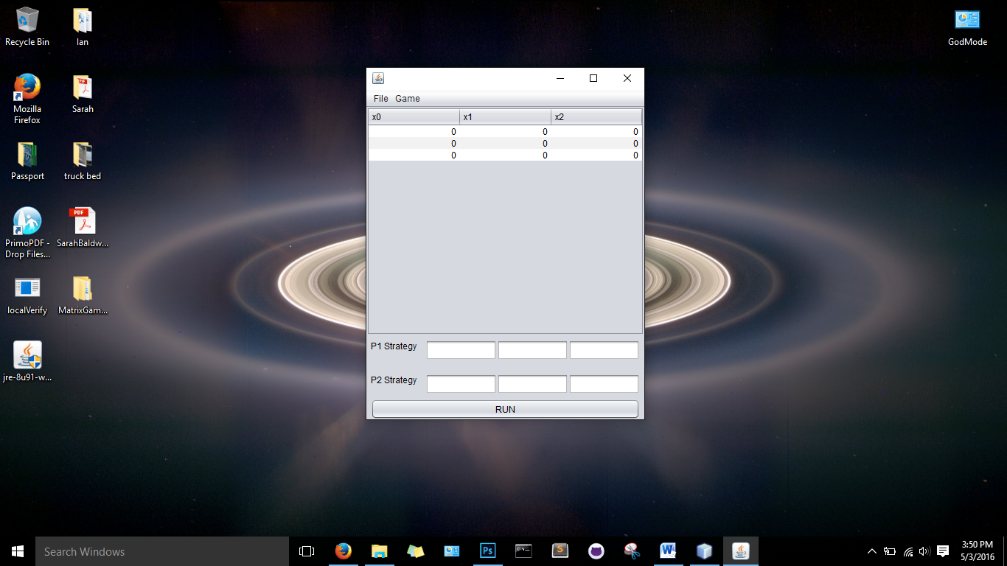 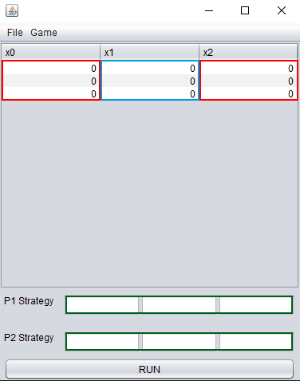

(Reference above image to the right) Here, you will be able to enter the numbers in the payoff matrix, in the red and blue boxes. x0, x1, and x2 are the column labels, and of course this game has 3 rows, making it a 3x3 matrix. The green boxes beside P1 Strategy and P2 Strategy are for the user to enter the probability (in decimal format) that P1 and P2 will play each strategy available to them to try to win (to either maximize or minimize their score).

Red & Blue box input:

* Can be any double/floating point value between -∞ to +∞ that makes sense for the particular game being played

Green box input:

* Any decimal entry combination that sums to 1, roughly (i.e. .33, .33, .33 or .5, .25, .25)

On the following page, a 2-player matrix game example has been entered into the simulator. The game payoff in this example happens to be for the game Penny, Nickel, Dime. The image also demonstrates how you can use the *Game* menu to *Populate Optimal* value from the given payoff matrix.

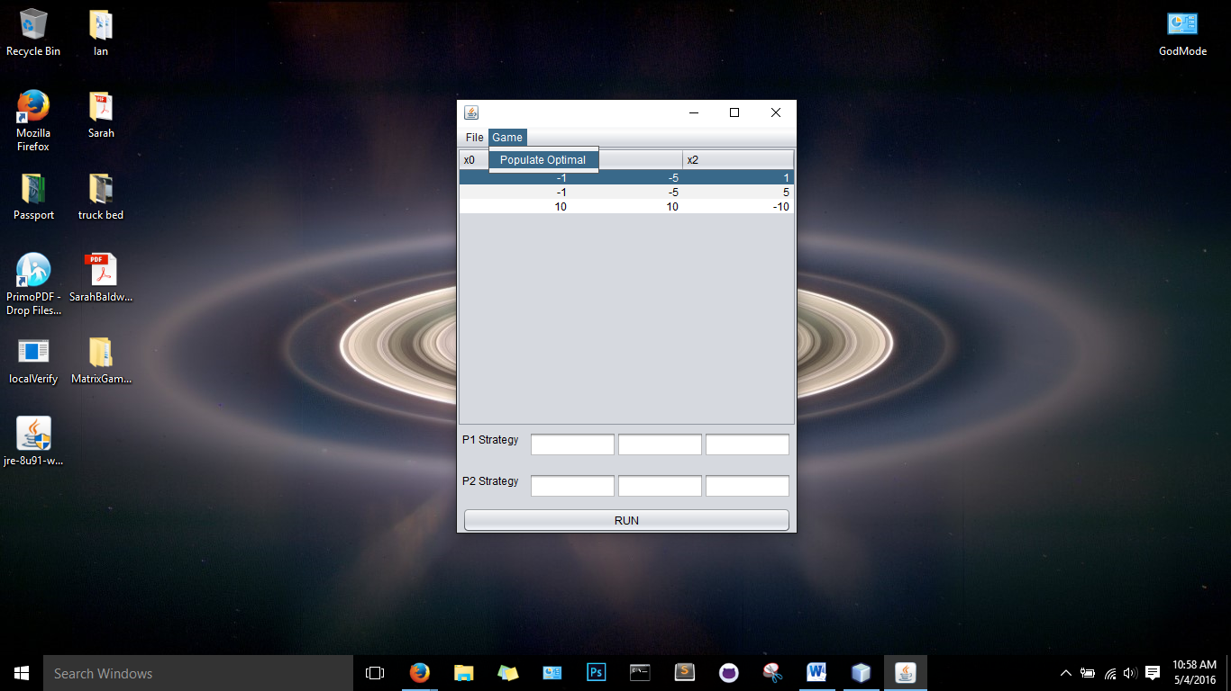 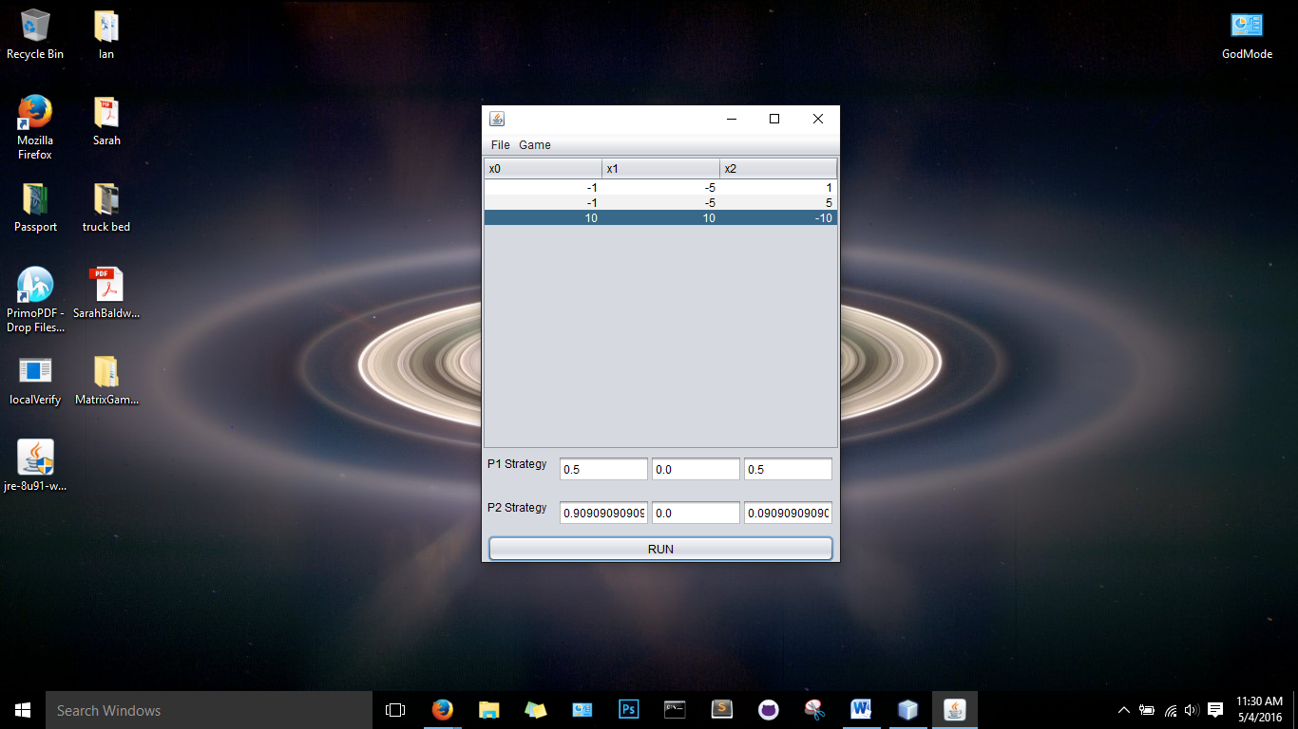

You can also enter your own probability for each strategy available to Player 1 and Player 2. As well as, *Save* and *Load* a game with the File menu, shown below (left). Then, click *Run* to see the results/payoff, also shown below (right)

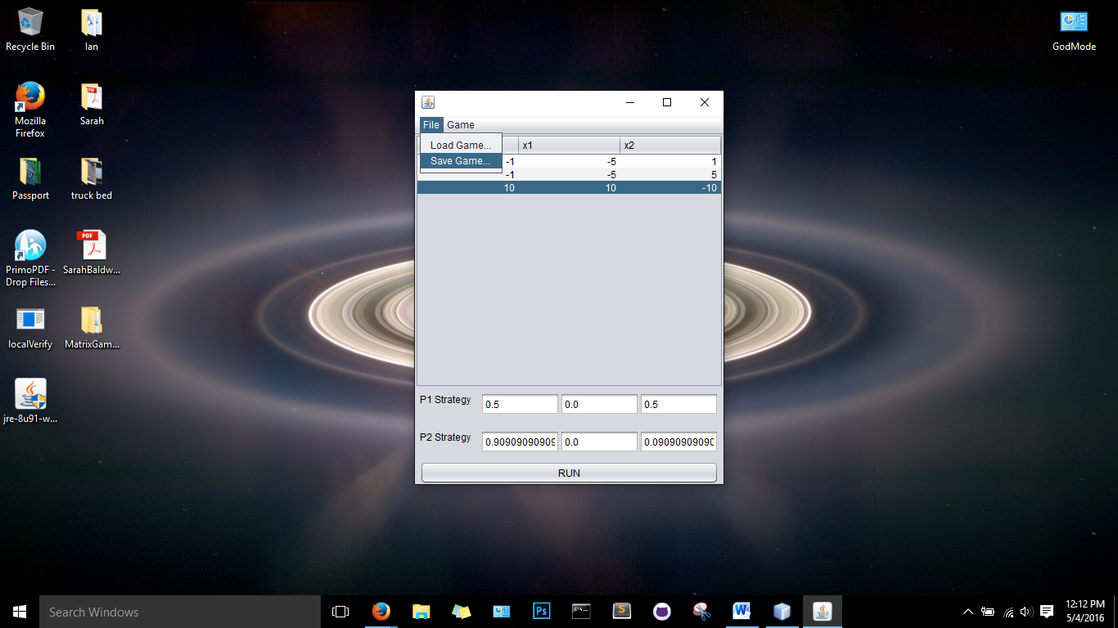 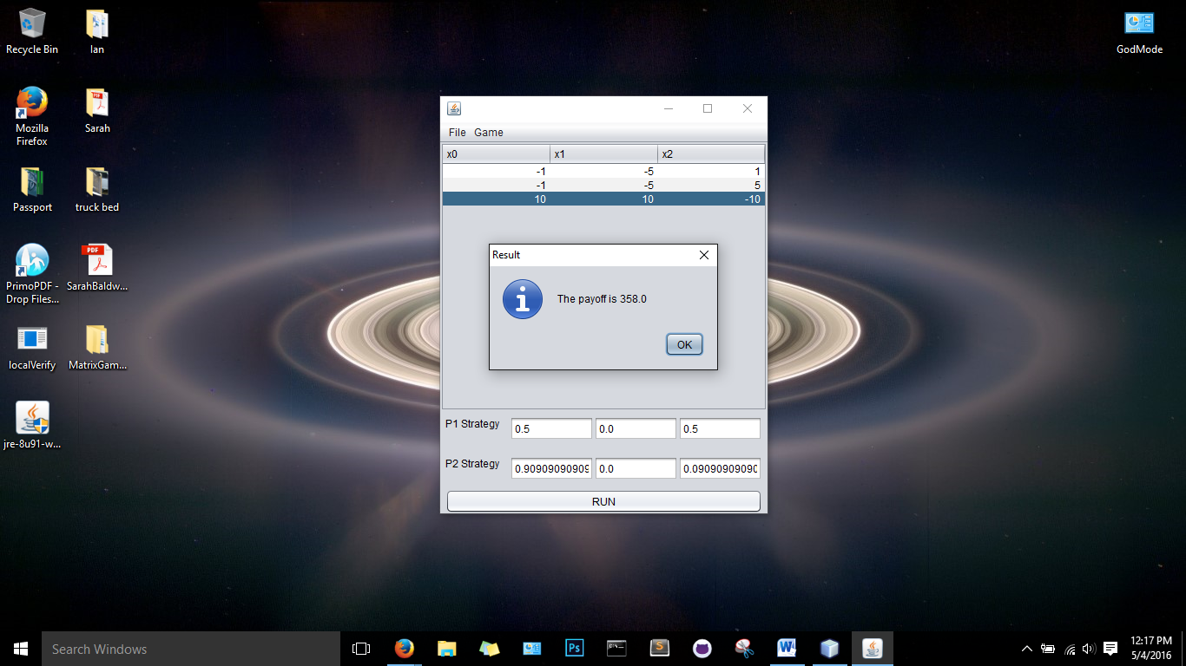

To start a new game or choose a different sized matrix (nxn) click *File*, then *New* *Game* and enter in the size of the matrix game you would like to play (i.e. enter 2 for a 2x2 matrix; detailed in picture below).

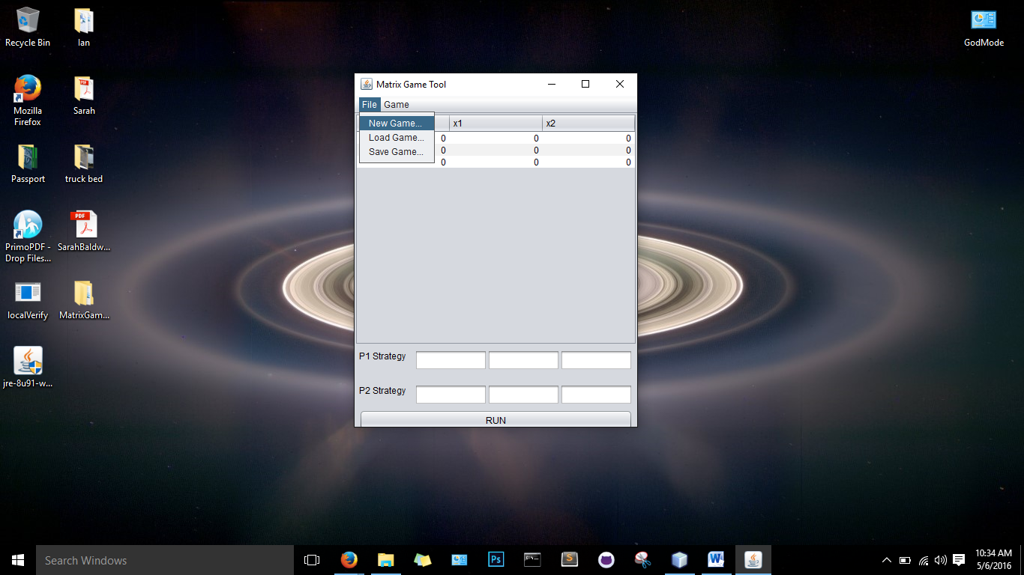 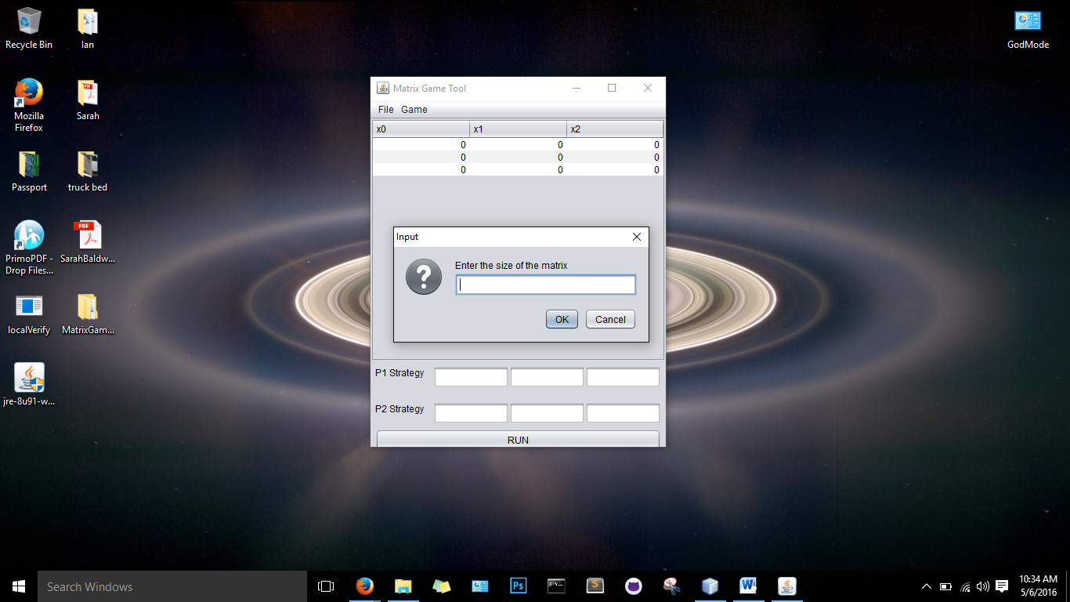

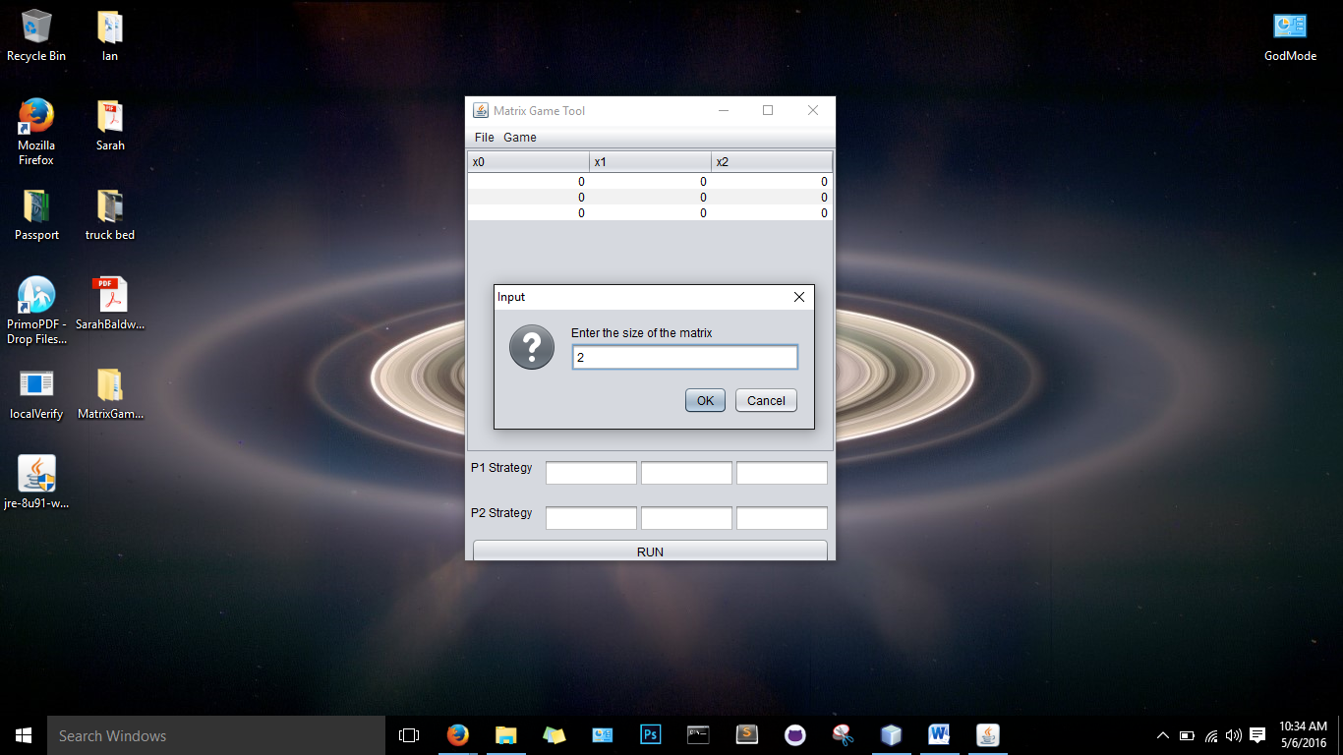 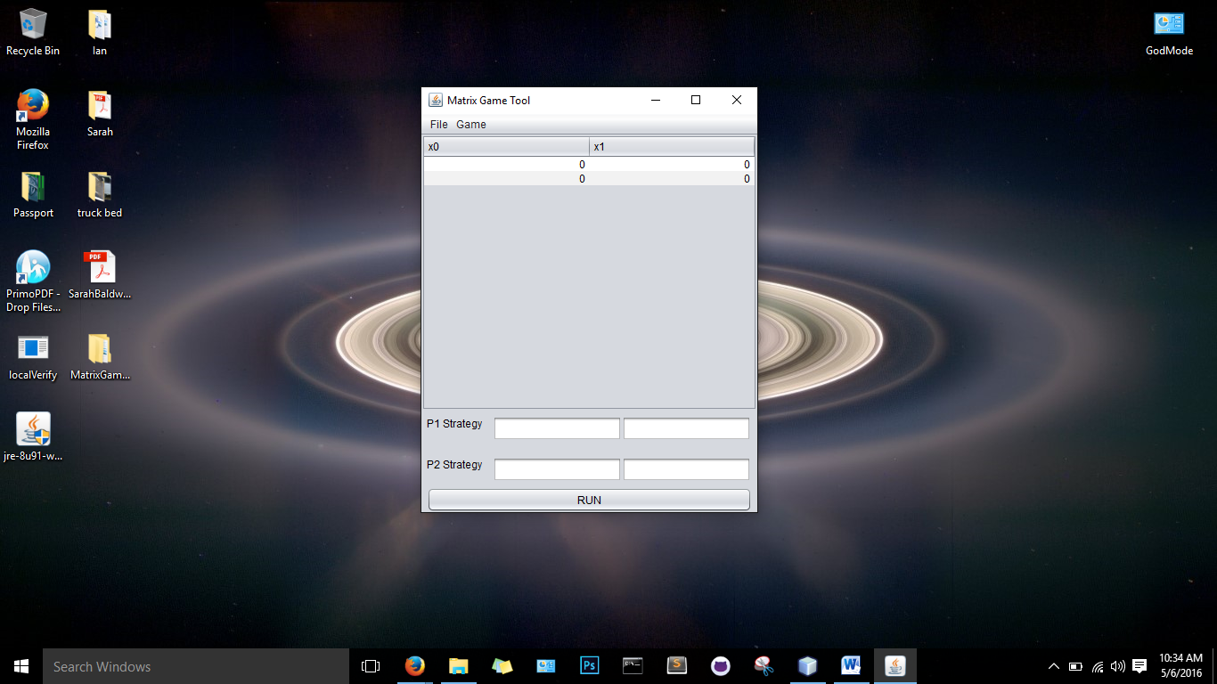

Copyright (C) 2016 mjw

This program is free software: you can redistribute it and/or modify it under the terms of the GNU General Public License as published by the Free Software Foundation, either version 3 of the License, or (at your option) any later version.

This program is distributed in the hope that it will be useful, but WITHOUT ANY WARRANTY; without even the implied warranty of MERCHANTABILITY or FITNESS FOR A PARTICULAR PURPOSE. See the GNU General Public License for more details.

You should have received a copy of the GNU General Public License along with this program.

If not, see <http://www.gnu.org/licenses>.